CSCE 623 Project First Draft

Rain Dartt

18 May 2021

# Introduction

The motivation behind the thesis topic sponsored by AFPC is to review resumes for technical positions using NLP techniques and determine if the specialized experience responses from applicants meet job posting requirements. This is a classification problem with two potential classes: meeting or not meeting the requirements. Currently, AFPC relies on human technicians who are not trained or familiar with field-specific jargon that often appears in these resumes, so misclassification is too common, resulting in time wasted on false positives and accusations of unfairness (and worse) from false negatives. While this thesis focuses only on the specialized experience open response text field, AFPC is investigating the process as a whole to find opportunities for increased accuracy or timeliness through automation.

Since AFPC is unable to provide a set of example resumes and true labels, the first step was exploring available data sets for compatibility. The available data that best fits the purpose of the thesis is a recently published corpus of legal contracts. According to the authors, “The dataset includes more than 500 contracts and more than 13,000 expert annotations that span 41 label categories” (Hendrycks et al., 2021, p. 2). The reason the number of annotations is not equal to the product of contracts and label categories is that not every contract includes an entry for every label. The master clauses csv file (manually curated by experts) contains a row for each contract and two columns for each label category: the first instance contains the phrase or clause that meets that label while the second condenses and standardizes it into a format that makes it easier to present. The existence of any non-blank data demonstrates that the category did apply to the contract in question.

Rather than asking “does this resume contain clauses that fulfill each of the specialized experience requirements?”, this data set can be used to ask the similarly-formed question of “does this contract contain clauses that meet one or more of the label categories requested?” Instead of going back to the contracts themselves to extract clauses that fit into categories using a model like the transformers in the article, the target of this project is to test a number of feature extraction methods and simpler classifier models that train on a subset of the data (sentences known to correspond with exactly one category label) and then predict the classification of test data. The F1 scores and confusion matrices produced over several randomized trials will provide a metric to compare the different models. The objective is to find the model (naïve bayes, logistic regression, or random forest classifier) that requires the fewest features to produce an average F1 score of over 0.9 based on a 10-fold cross evaluation. The initial hypothesis is that, using the same number of features, logistic regression will perform best, followed by naïve bayes and then random forest. Research questions include which specific features to include for the best performance, and how much the imbalance of classes will affect the models.

# Related Work

Pranckevičius and Marcinkevičius (2017) used five classification methods (including the three proposed for this project) on to label Amazon customer reviews on a scale (classes) of 1 to 5. Their data set was much larger and had fewer class options, but there is common ground in the size/length of each text sample, exclusivity of classes (multi-class not multi-label), and the desire to not use tf-idf (they used an n-gram bag of words approach) as the feature extraction method. The image below is a figure from their report that summarizes the workflow model; a similar image will be produced in my final report with details that match. This format is more intuitive than the data science trajectories. Their results heavily informed my hypothesis about the ranking of the three models discussed in the introduction; however, I hope to achieve higher performance scores by using more and better features. I also employ a lemmatizer instead of a stemmer after tokenization, but that is unlikely to have a large effect.

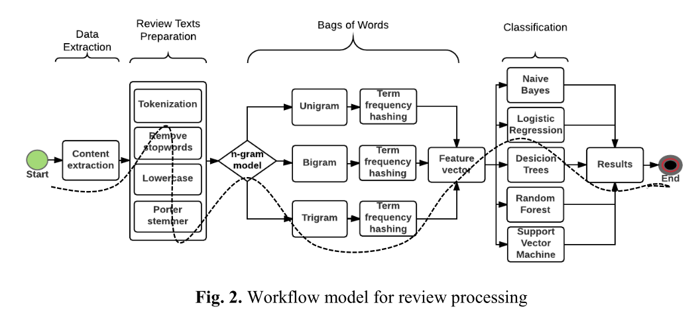

Figure . Workflow model from Pranckevičius and Marcinkevičius (2017)

Despite the lower performance of the random forest classifier observed in the paper above, I am still interested in including it if for nothing other than the appeal of the decisions of tree models being easier to visualize and interpret than logistic regression (in general; this is less true for random forests). Of the decision tree methods described in the textbook, random forest performed the best, so that is the one I will implement (James et al., 2013). The random forest method has a randomly constrained window of predictors it is allowed to decide on at each level, so it is important to run the model many times and take the average of scores. Agrawal et al. (2013) were able to outperform previous models with a multilabel random forest in the domain of web page recommendation; however, their data set was much larger than the one for this project.

Roy, Chowdhary, and Bhatia (2020) also test random forest, naïve bayes, and logistic regression (in addition to a linear support vector classifier) and rank the three in the same order as my above hypothesis (though LSVM was the top). Their domain was actually about resumes and job descriptions, which pairs very well with my thesis and project. One difference is that job descriptions are not quite equivalent to a specialized experience requirement, but the underlying theory and methods are nearly identical. The figure below is their version of a workflow that is also worth including for reference as it is a worthy design to mimic.

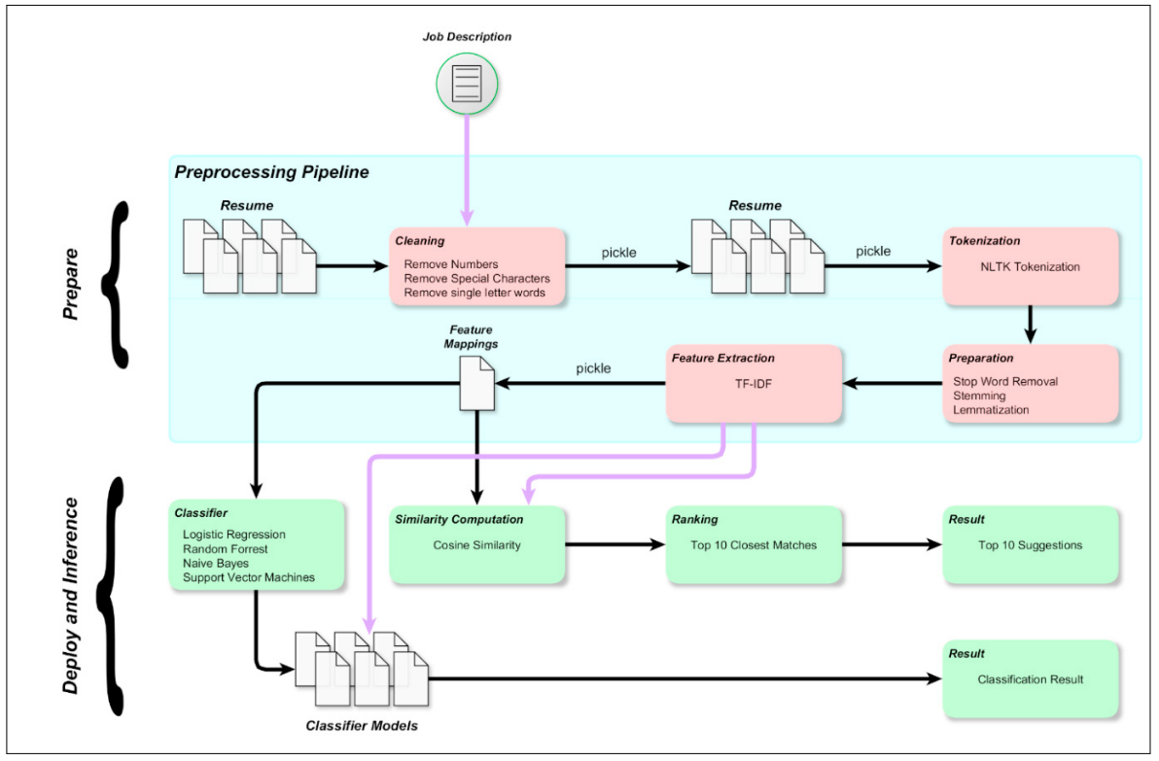

Figure . Model Framework from Roy, Chowdhary, and Bhatia (2020)

# Approach/Methodology

Performance of the models will use the F1 score based on precision and recall and will be presented in tabular and confusion matrix form. There is truth data available for scoring purposes. Classes are mutually exclusive labels; which class the model predicts as most likely will be the one counted for scoring as either correct or incorrect; there will be no partial points given if the correct class was the second- or third-highest predicted class. While I do expect the relative ranking of the three models to match examples from other research, I am not expecting the actual values of the scores to match (they do not match across literature, either) since it is very domain dependent.

To collect the scores, I will perform 10-fold cross validation using sklearn’s Python packages. The models themselves will also be imported from sklearn, but at least some of the feature extraction options will be custom written. I have already tried word2vec and Tfidf vectorizer with confusing results, but I may try again with data organized in a more effective way. I can use the results from sklearn to view the confusion matrix and try to adjust the models based on the types of errors seen.

So far, I went down a few rabbit holes in the wrong direction, but I have a clearer path forward. I am taking small steps and trying to keep the Python Notebook tidy and efficient, with helper functions in separate files and processed data stored and read from files instead of re-running steps that have been completed. Below is an example of the dataframe containing the preprocessed sentences (x data) and the label category (y data). The next step will be to encode the ‘Category’ as an integer 0 to 24 and to translate the sentences into numerical vectors. There are a total of 3611 sentences from the original 510 contracts and 32 features of interest. I selected the 32 features whose ‘answer’ column was a simple ‘Yes/No’ option, which excluded the very short features such as dates and state/country of governing law since those were all very short fields that did not seem interesting. Figure 4 shows the distribution of categories per sentence.

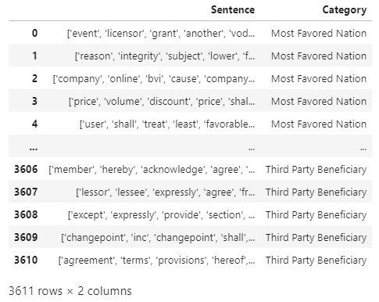

Figure . Pandas Dataframe of Preprocessed Contracts

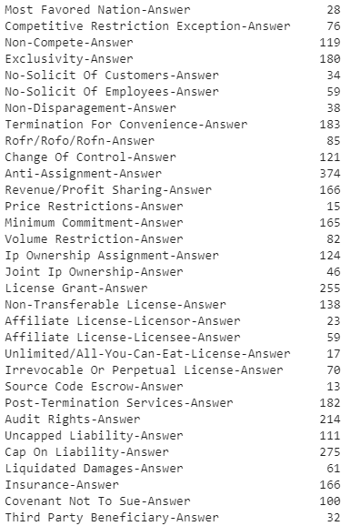

Figure . Number of Sentences per Category

# Expected Results and Error Analysis

I have not yet finished the feature extraction required before running any of the models. I attempted to import and apply word2vec and tf-idf functions, but I had an incorrect version of the x-data, so the results were meaningless. I am also trying to avoid tf-idf since the entire document is contract legalese and unlikely to transform well, but I will still test it since it should be easy to implement.

If the results confirm the same ranking of the three models as found in literature, I will have some confidence that I implemented the models correctly. I may also be inspired to implement a support vector model in the future. For my overall thesis, I eventually need to work in the full text contracts, of which 90-99% of the sentences would be properly classified as ‘None’ compared to the features investigated here. That is a problem with even worse class imbalance than this one, but the increased observation count could mean tf-idf methods become more reliable.

Bibliography

Agrawal, R., Gupta, A., Prabhu, Y., & Varma, M. (2013). Multi-label learning with millions of labels: Recommending advertiser bid phrases for web pages. *WWW 2013 - Proceedings of the 22nd International Conference on World Wide Web*, 13–23.

Hendrycks, D., Burns, C., Chen, A., & Ball, S. (2021). *CUAD: An Expert-Annotated NLP Dataset for Legal Contract Review*. [http://arxiv.org/abs/2103.06268](http://arxiv.org/abs/2103.06268%20)

James, G., Witten, D., Hastie, T., & Tibshirani, R. (2013). An Introduction to Statistical Learning. In *Springer Texts in Statistics*. http://books.google.com/books?id=9tv0taI8l6YC

Jurafsky, D., & Martin, J. H. (2020 draft). *Speech and Language Processing*. 1–623.

Pranckevičius, T., & Marcinkevičius, V. (2017). Comparison of Naive Bayes, Random Forest, Decision Tree, Support Vector Machines, and Logistic Regression Classifiers for Text Reviews Classification. *Baltic Journal of Modern Computing*, *5*(2), 221–232. https://doi.org/10.22364/bjmc.2017.5.2.05

Roy, P. K., Chowdhary, S. S., & Bhatia, R. (2020). A Machine Learning approach for automation of Resume Recommendation system. *Procedia Computer Science*, *167*(2019), 2318–2327. https://doi.org/10.1016/j.procs.2020.03.284

Appendix A.

Master Clauses CSV

